**EXPERIMENT 12:**

Create a Virtual Machine with 1 CPU, 2GB RAM and 15GB storage disk using a Type 2 Virtualization Software

**AIM:**

To create a virtual machine with 1 cpu, 2gb ram and 15gb storage disk using a type 2 virtualization software**.**

**PROCEDURE:**

**STEP 1:**Download VMware workstation and installed

**STEP 2:** In VMware workstation->create new VM.

**STEP 3:** Do the basic configuration settings.

**STEP 4:** Created tiny OS virtual machine.

**STEP 5:** Launch the VM.

**IMPLEMENTATION:**

**STEP 1:DOWLOAD VMWARE WORKSTATION AND INSTALLED AS TYPE 2 HYPERVISOR**

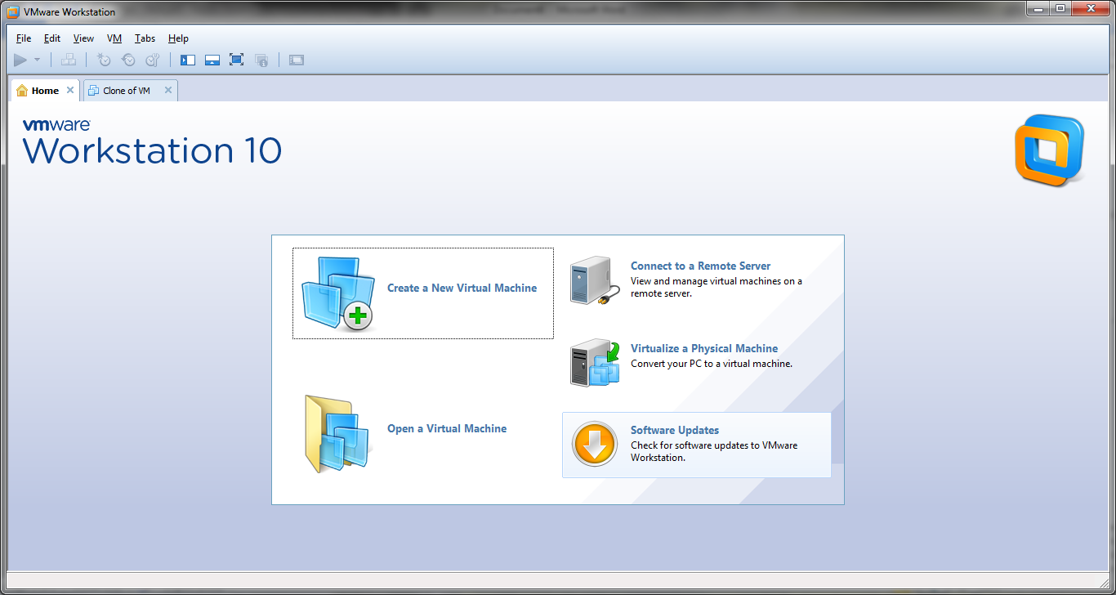

**STEP 2: IN VMWARE WORKSTATION->CREATE NEW VM**

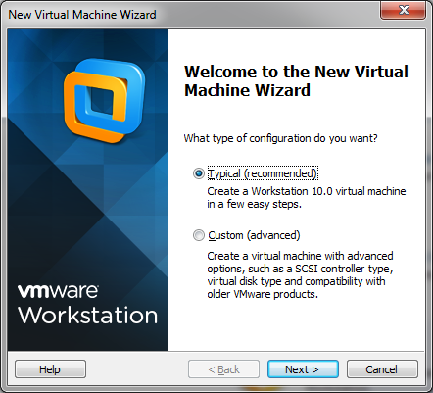

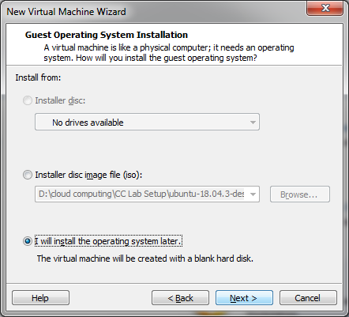

**STEP 4: DO THE BASIC CONFIGURATION SETTINGS.**

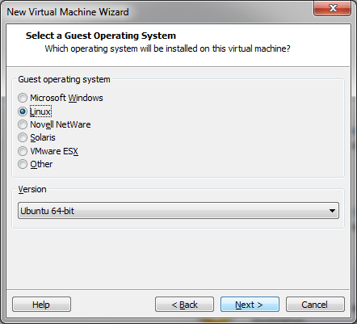

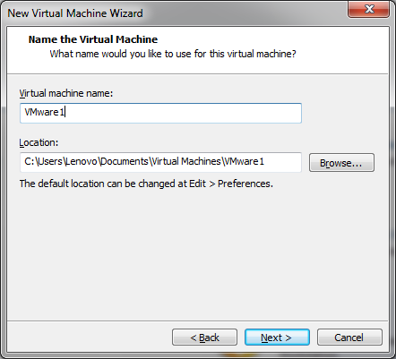

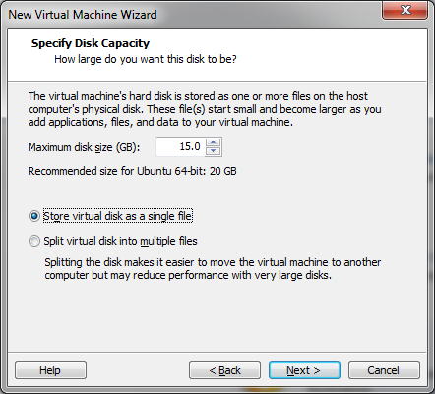

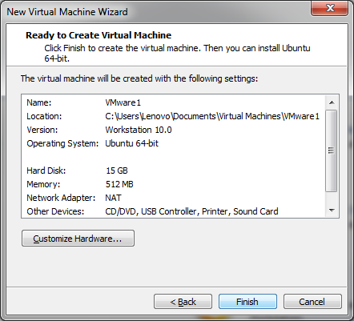

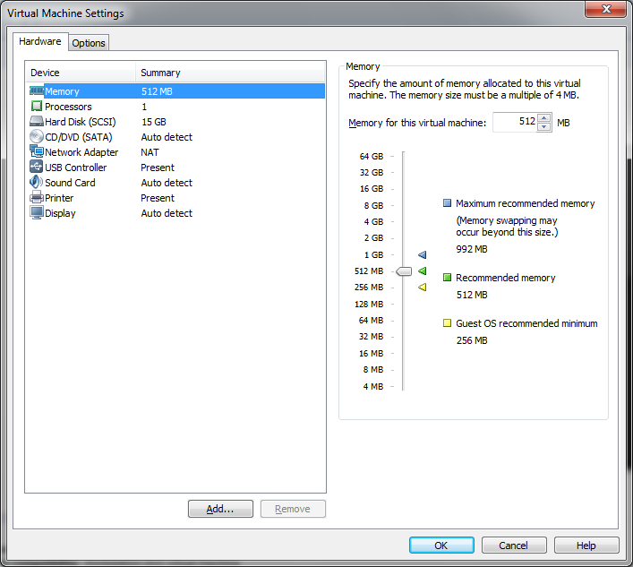

**STEP 5: CREATED VIRTUAL MACHINE**

